CYB 220 Module Four Activity Worksheet

Directions: Complete the guided tutorial activity using the Module Four Activity Student File available in the learning environment. Follow the steps outlined below in Packet Tracer. You will be asked to provide screenshots or answers to the questions as instructed. Complete this template by replacing the bracketed text with the relevant information.

Part I: FTP Server

FTP Access Configuration
Step 1: In the Services Tab of the FTP_Server_Public, ensure the FTP services are on. Notice that this service has a default admin account. (The username and password are both cisco). You will use this account for any testing.

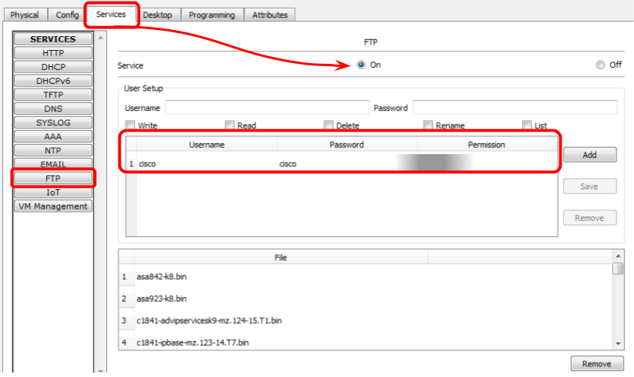

Question 1: What are the permissions for the default FTP user cisco?

The default permissions are: Read, Write, Delete, Rename and List

Step 2: From Server1_Admin, access the Command Prompt (from the Desktop tab). Use the FTP <IP Address> command, and log in with the default Cisco FTP account credentials:

Packet Tracer PC Command Line 1.0
C:\>FTP 10.1.10.5
Trying to connect...10.1.10.5
Connected to 10.1.10.5
220- Welcome to PT Ftp server
Username:

Use the dir command (for directory) for a list of all the files hosted on the FTP server.

Question 2: What is file number 8 in the FTP directory?

File number 8 is: c2600-ipbasek9-mz.124-8.bin

Part II: Host-Based Firewall
Type the command ftp>quit before starting Part II.

Configure the Firewall on the FTP_Server_Public
Step 1: From the Desktop Tab, open the IPv4 Firewall application:

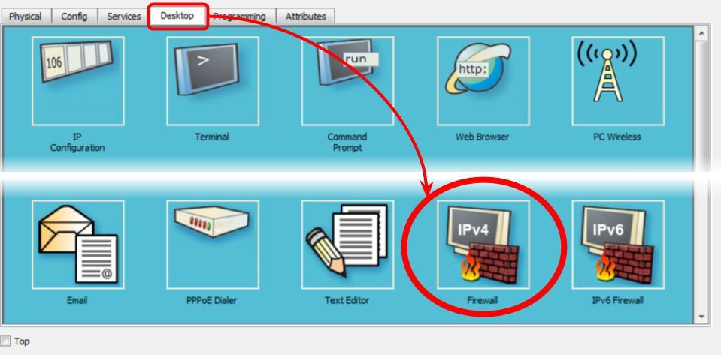

Step 2: Add a firewall rule according to the following settings:
- Service: “On”
- Interface: FastEthernet0
- Action: “Deny”
- Protocol: “ICMP”
- Remote IP: 192.168.1.101
- Remote Wildcard Mask: 0.0.0.0
- Click “Add.”

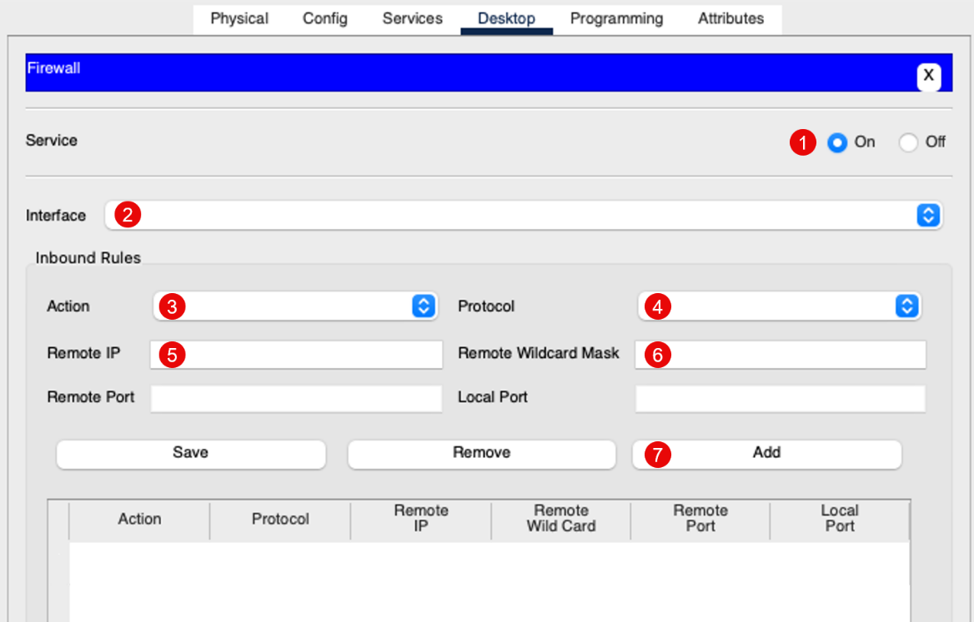

Screenshot 1: Add a screenshot of the proper firewall rule in place.

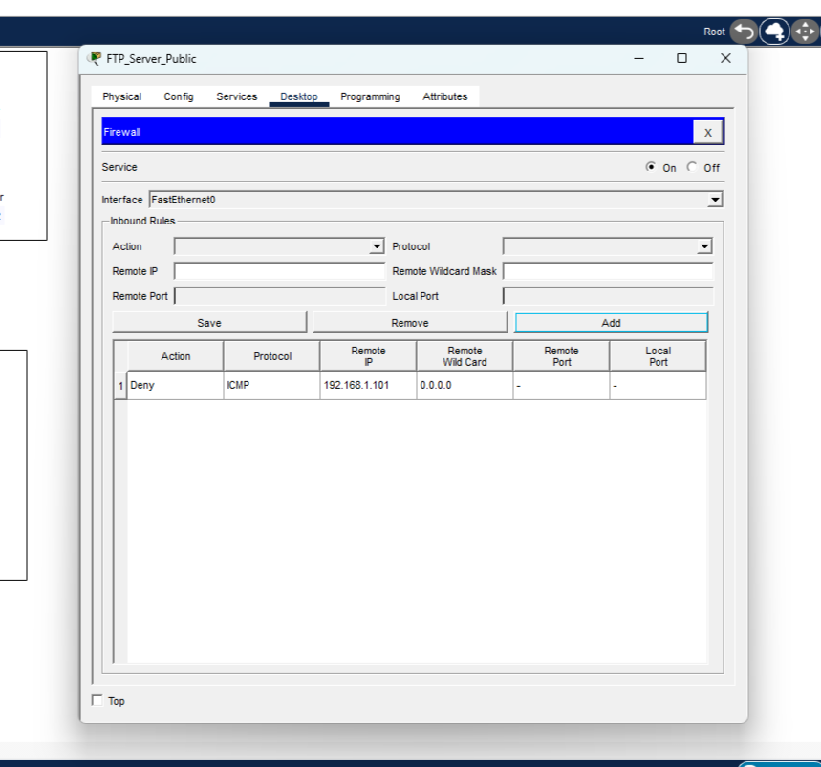

Test the Firewall Rule
Step 1: From Server1_Admin (192.168.1.101), use FTP in the command prompt to attempt to connect to the FTP server (10.1.10.5).

Question 3: This connection is prevented if your firewall configuration is correct. What is the error message you receive when this connection is unable to be made?

The error message is: %Error opening ftp://10.1.10.5/ (Timed out)

Modify the Firewall Rules
Step 1: From PC1_End_Users (in the End User network), ping the FTP server (10.1.10.5). You should receive a “Request timed out” message. Why? The Firewall Service is configured in a default-deny stance. By activating the Firewall Service and applying at least one Inbound Rule, all other traffic is denied unless allowed by exception using another rule.

Step 2: To allow specific traffic, you will need to add another rule to the FTP Server host-based firewall. Imagine you would like only the hosts in the End_User network to access the FTP services on the FTP Server. You have the options following this paragraph available to be applied. Feel free to test each out in Packet Tracer before answering Question 4.

Option One:
Action | Protocol | Remote  IP | Remote Wildcard | Remote  Port | Local  Port
Allow | IP | 192.168.2.101 | 0.0.0.0 | any | 21

Option Two:
Action | Protocol | Remote  IP | Remote Wildcard | Remote  Port | Local  Port
Allow | IP | 192.168.0.0 | 0.0.255.255 | any | 21

Option Three:
Action | Protocol | Remote  IP | Remote Wildcard | Remote  Port | Local  Port
Allow | IP | 192.168.2.96 | 0.0.0.15 | any | 21

Option Four:
Action | Protocol | Remote  IP | Remote Wildcard | Remote  Port | Local  Port
Allow | IP | 192.168.2.0 | 0.0.0.255 | any | 21

Question 4: Which option is the best to allow only the hosts in the End_User network to access the FTP services on the FTP Server? Why did you recommend this rule?

I chose option 4 because it allows traffic from that subnet but not the others like option 2 would. Option 1 and option 3 only allow a specific IP address.

Before moving on to Part III, be sure you have configured your selected rule on the FTP server before moving forward to the next question.

Part III: Standard Access List

Create the Standard Access List Control List
Standard access control lists (ACLs) can be configured in two ways:
- Numbered access list using the command #access-list <#1-99>
- Named access list using the command IP access-list standard <#1-99 or name>

Once created, both will function identically; however, named access lists provide the advantage of being editable. With a numbered list, you must first delete the entire ACL, then recreate it with any edits you require. In this tutorial, you will use the named ACL to allow us to explore the results of making changes.

Step 1: Go to the CLI tab in the Office Router:

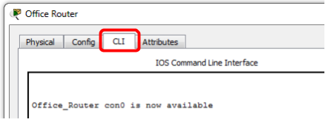

Step 2: Create the Standard Access List:

Office_Router>enable
Office_Router#configure terminal
Office_Router(config)#ip access-list standard officeFTP
Office_Router(config-std-nacl)#deny any
Office_Router(config-std-nacl)#exit
Office_Router(config)#exit
Office_Router#
%SYS-5-CONFIG_I: Configured from console by console

Office_Router#show access-lists

Screenshot 2: Add a screenshot of your configured access list.

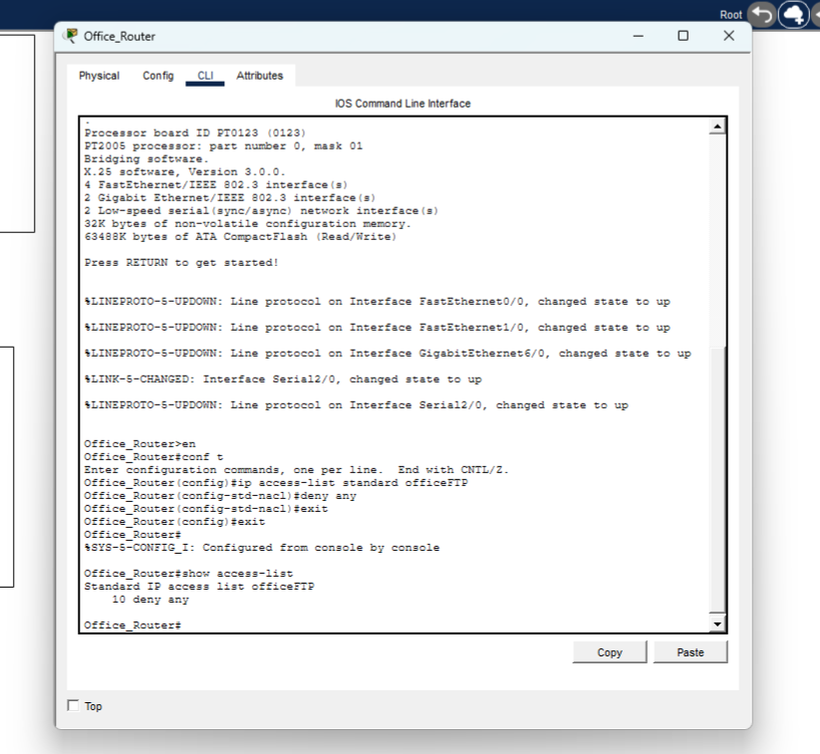

Apply the Standard Access Control List Named Office to the Gigabit Ethernet 6/0 Interface
Routers/firewall appliances filter traffic with access control lists (ACLs) assigned to a specific interface. The processing and filtering of traffic is affected by whether the ACL is designated as inbound or outbound. In this tutorial, the standard ACL, officeFTP, will be applied to the g6/0 interface as an outbound ACL. Before forwarding traffic out of the g6/0 interface, the router checks the source IP address against the ACL. If the packet source is from a “deny” address, the packets are discarded. If they are from a “permit” address, they are forwarded.

Step 1: Go to the CLI tab in the Office Router:

Step 2: Apply the standard access control list to a specific interface.

Office_Router#configure terminal
Office_Router(config)#interface g6/0
Office_Router(config-if)#ip access-group officeFTP out
Office_Router( config-if)#exit
Office_Router(config)#exit
%SYS-5-CONFIG_I: Configured from console by console

Step 3: From PC1_End_Users, use the command C:\>ftp 10.1.10.5 to access the FTP Server.

Question 5: Explain the interaction between the FTP’s host-based firewall and the router’s access list.

The router's access list is set to deny all trafÏc; therefore, any attempt to connect to the
FTP using the address 10.1.10.5 would fail because the router blocks the trafÏc from reaching the
server.

Modify the Standard ACL on Gig6/0:
Step 1: Go to the CLI tab in the Office Router:

Step 2: Add a new rule to the standard ACL.

Office_Router_>enable
Office_Router#configure terminal
Office_Router(config)#ip access-list standard officeFTP
Office_Router(config-std-nacl)#permit 192.168.2.0 0.0.0.255
Office_Router(config-std-nacl)#exit
Office_Router(config)#exit
%SYS-5-CONFIG_I: Configured from console by console

Step 3: From PC1_End_Users, use the command C:\>ftp 10.1.10.5 to access the FTP Server.

Question 6: Explain why the connection times out despite adding the “permit” statement for the End_User network to the ACL.

The outbound application of the ACL officeFTP is on interface g6/0. Thus, the amount of data that
may leave the router via this port is limited

Edit the Standard ACL on Gig6/0
Step 1: Go to the CLI tab in the Office Router:

Step 2: Edit the standard ACL.

Office_Router>enable
Office_Router#configure terminal
Office_Router(config)#ip access-list standard officeFTP
Office_Router(config-std-nacl)#no 10
Office_Router(config-std-nacl)#exit
Office_Router(config)#exit
%SYS-5-CONFIG_I: Configured from console by console
Office_Router#show access-lists

Screenshot 3: Add a screenshot of your configured access list.

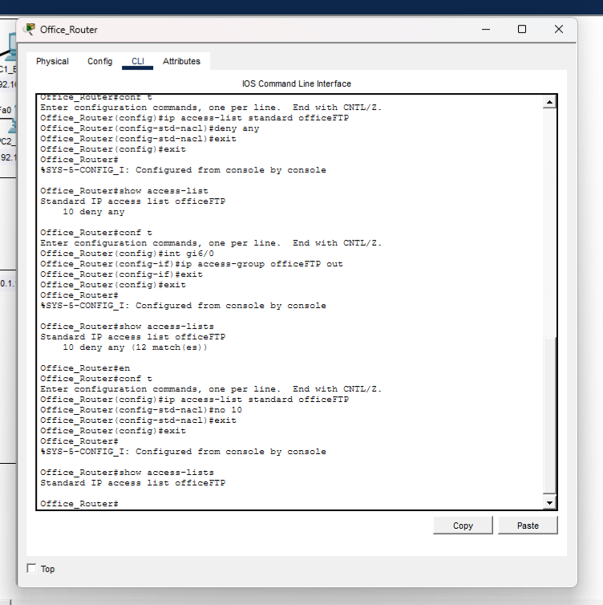

FTP Server Access
Step 1: Use the command C:\>ftp 10.1.10.5 to access the FTP server from:
- PC1_End_Users
- Kiosk1_Remote_Access

Question 7: Explain the effects of editing the office FTP ACL. Why are the two hosts above permitted or denied access to the FTP server?

The PC1 is allowed access because the rule 10 was eliminated on the router but the ftp server still has a firewall rule to deny traffic from any excpet the end user subnet.

Part IV: Extended Access Control List
Extended Access Control List (ACL) was implemented to filter specific protocols without the need to call out specific hosts/network addresses.

Show Kiosk1_Remote_Access Initially Has Access to Server1_Admin File Server:
Step 1: Use the Desktop Menu to access the Web Browser:

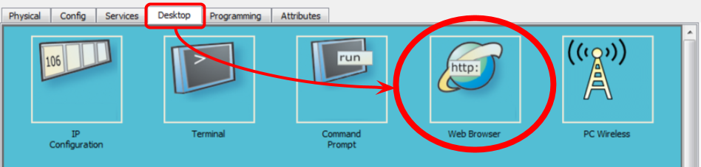

Step 2: Navigate to File server on Server1_Admin (192.168.1.101).

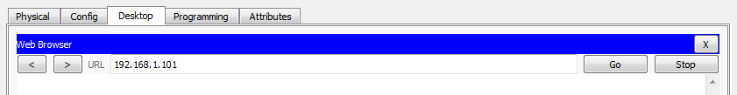

Screenshot 4: Add a screenshot of your results attempting to access the file server.

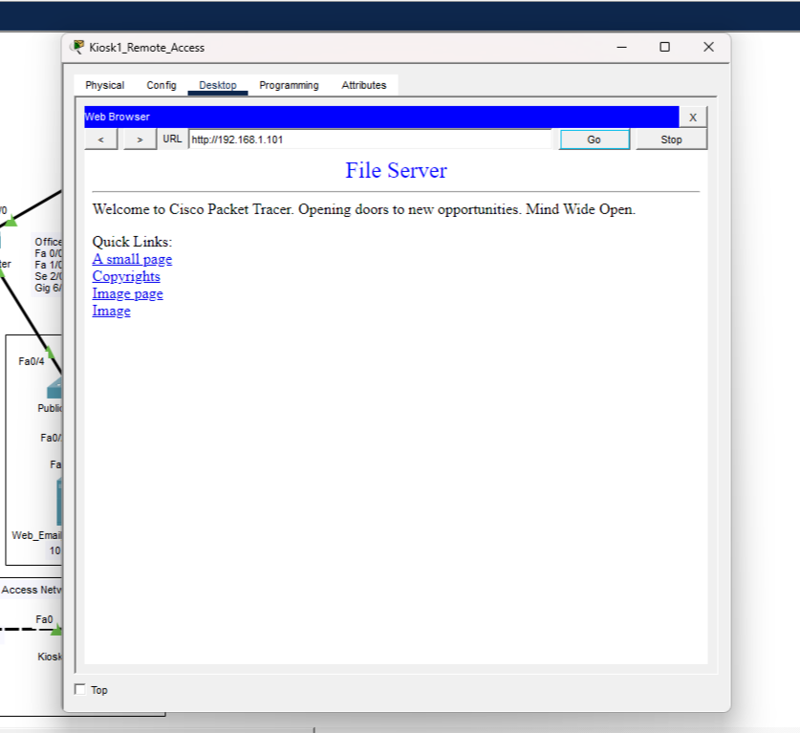

Configure Remote_Router Extended ACL for SMTP/POP3 Traffic to Email Server
Step 1: In the Remote_Router CLI tab, add:

Remote_Router>enable
Remote_Router#configure terminal
Remote_Router(config)#ip access-list extended email
Remote_Router(config-ext-nacl)#permit tcp 192.168.3.2 0.0.0.0 host 10.1.10.6 eq smtp
Remote_Router(config-ext-nacl)#permit tcp 192.168.3.2 0.0.0.0 host 10.1.10.6 eq pop3
Remote_Router(config-ext-nacl)#exit
Remote_Router(config)interface g0/0/1
Remote_Router(config-if)#ip access-group email in
Remote_Router(config)#exit
%SYS-5-CONFIG_I: Configured from console by console

Step 3: Compose email from Kiosk1 to PC1_End_User (office1@central-branch.pt.pka).

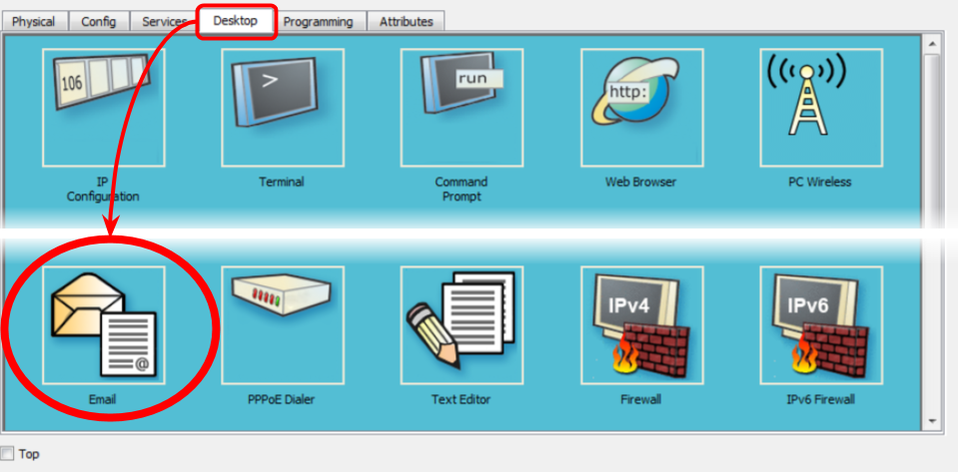

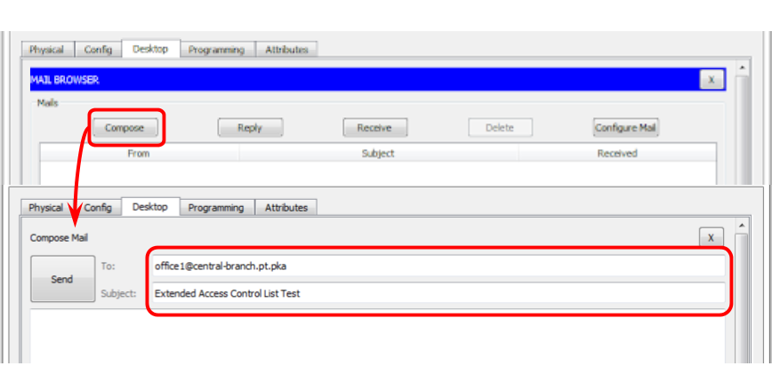

Step 4: Confirm PC1_End_User’s inbox contains the received email from Kiosk1.

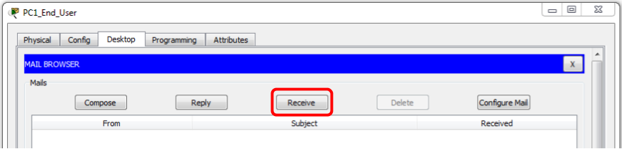

Screenshot 5: Add a screenshot of PC1_End_User’s inbox containing the received email.

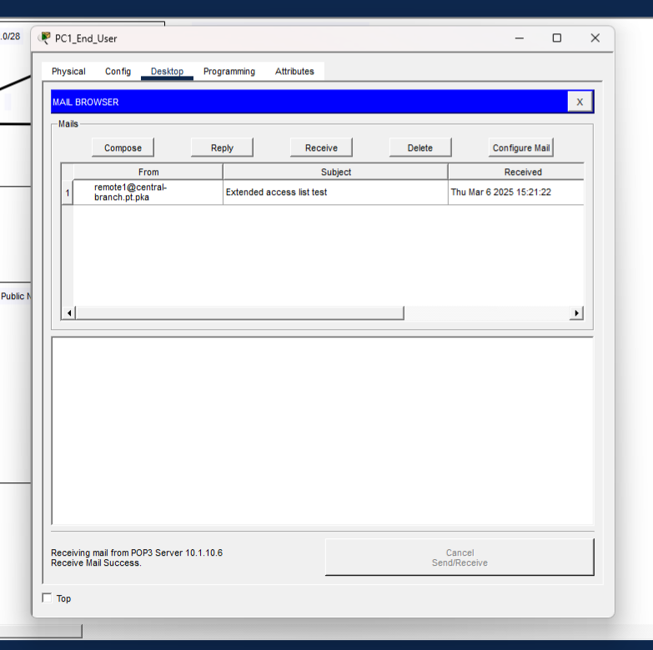

Step 5: Verify That the ACL Has Prevented Access to the File Server
  - Use the Desktop Menu to access the Web Browser:

- Navigate to the file server on Server1_Admin (192.168.1.101).

Screenshot 6: Add a screenshot of the file server.

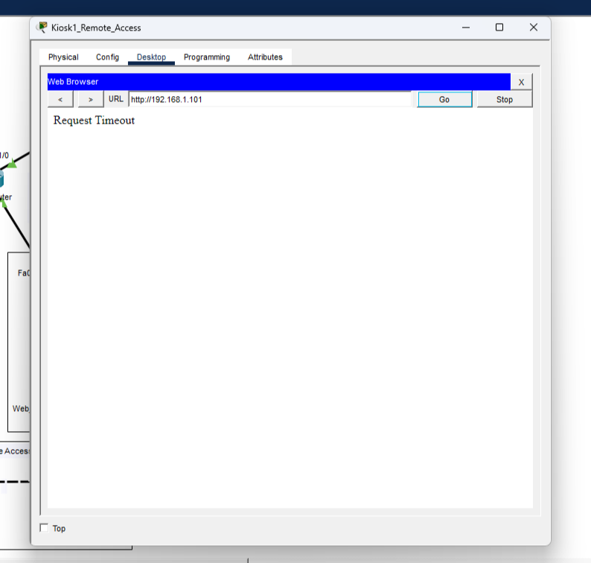

Question 8: How would you configure the Extended ACL for scalability? In other words, how could you set up the extended ACL to avoid having to modify the ACL every time you add a new host?

You would set up the extended ACL by subnets so as new users go on in the same subnet they will automatically be allowed access.

